**THE ECONOMIC IMPACTS OF ROAD ACCIDENTS AND CASUALTIES ON THE UK’s GDP (2021 & 2022)**

A thrilling exploration using data analysis techniques to visualize and uncover insights into road accidents, the average cost of accidents and casualties, and the GDP of the UK.

 **Balogun Olumide Chris**

**April 2024**

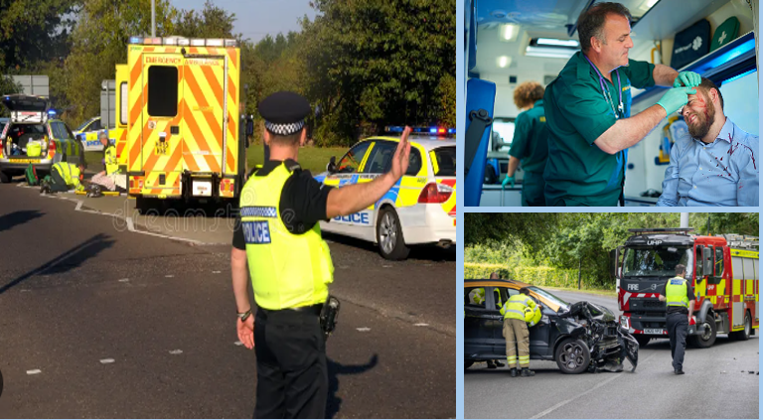

A few months back, I stumbled upon an article dissecting the impact of COVID-19 on the global economy. It ignited a spark within me, prompting me to delve into the realm of data analysis. My focus shifted to studying road accidents in the UK. But that wasn't enough. I felt compelled to dive deeper, intertwining this analysis with factors such as the average cost per accident and casualty in the UK, as well as the GDP of the nation in both 2021 and 2022. This resulted in the title: 'The Economic Impacts of Road Accidents and Casualties on the UK's GDP.'

Let's begin by examining the significance of the following terms to gain a clearer understanding of this article.

**What is Vehicular transportation?**

Vehicular transportation, involving cars, trucks, buses, motorcycles, bicycles, and trains, forms the backbone of modern infrastructure. It facilitates daily commuting, commerce, and the movement of goods and services. Without it, economic development and social connectivity would suffer significantly.

**What is road accident casualties by severity?**

Road accident casualties by severity" involves sorting individuals involved in road accidents according to the severity of their injuries. This categorization usually encompasses**:**

* **Fatalities:** Those who are killed in road accidents.
* **Serious injuries:** Individuals with severe injuries needing hospitalization or extensive medical care.
* **Slight injuries:** People with minor injuries not requiring hospitalization but may need medical attention or first aid.

This categorization helps authorities and policymakers understand the impact of road accidents on public health and safety, aids in creating preventive measures, allocates resources for emergency and medical services, and improves road infrastructure. It also offers insights into the effectiveness of road safety initiatives.

**What is GDP?**

Gross Domestic Product (GDP) serves as a crucial measure to assess a country’s economic performance. It quantifies the total monetary value of all goods and services produced within a nation’s borders during a specific period—typically annually or quarterly. GDP acts as a vital indicator of economic health, enabling comparisons between countries and tracking economic trends over time.

**What are Economic impacts?**

Economic impacts encompass the diverse effects of events, policies, or phenomena on economies at various scales. These impacts include changes in production, employment, wages, prices, consumption, investment, and overall economic growth. Analysing these impacts is essential for informed decision-making by policymakers, businesses, and individuals.

With a solid grasp of these critical topics at hand, let's delve into the subject matter. Keep in mind that this discussion intertwines three pivotal aspects of life.

**Let's break it down.**



This concise text outlines the significant stages involved in the project through a simple yet informative graphic. However, for some, reading textual descriptions might be more accessible than interpreting graphical representations of data wrangling processes.

1. Data Collection: Acquired via Web Scraping.
2. Preprocessed data in Excel and MySQL.
3. Data Cleaning: Rectifying spelling errors, eliminated blank entries, and omitted irrelevant columns specific to the project's scope.
4. Data Transformation: Altered the data to facilitate analysis. Converted the calendar column into a functional format by splitting it into separate columns for month and year.
5. Data Integration: Consolidated information from various sources into a cohesive dataset. Joining the information from the average cost per accident and casualty in the UK, as well as the GDP of the nation in both 2021 and 2022 to the dataset of road accidents in UK (2021 and 2022) using MySQL.

As with all data analytics projects, everything starts and ends with the data. My next focus will be on data exploration and validation as we embark on this critical analysis of the economic impacts of road accidents and casualties on the UK's GDP. Let's ensure a smooth journey.

**Examining the total number of vehicles involved in a specific traffic incident. This encompasses all cars, trucks, motorcycles, bicycles, and any other types of vehicles, whether directly or indirectly involved, regardless of the extent of damage or their role in the accident.**

Let's begin our initial data exploration by analyzing and visualizing the data to uncover insights.

1. **Good news!** In 2021, there were 298,687 vehicles involved in road accidents in the UK. In 2022, this number dropped to 264,615, representing a significant 11.4% year-over-year decrease. **Outstanding contributions from all stakeholders.**
2. During 2021, cars constituted 80% (238,904) of all vehicles involved in road accidents, and in 2022, they remained a significant portion, representing 79.5% (238,904) of total vehicle involvement. This decline from 2021 to 2022 indicates a decrease of 12% in car accidents. **That's a well-known fact since cars outnumber all other types of vehicles on the road.**

1

2

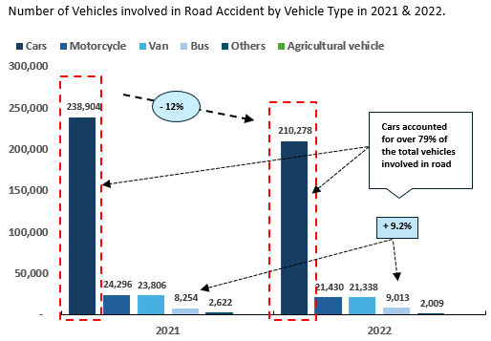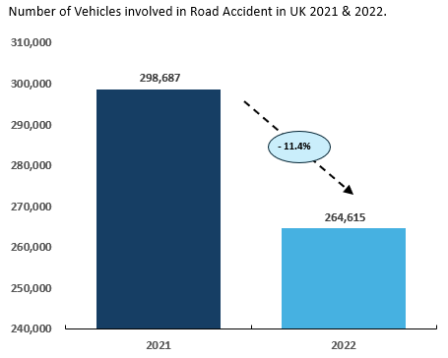

1. The UK witnessed its highest vehicle involvement in road accidents in Nov. 2021 and 2022, with 28,491 and 25,019 vehicles respectively. These incidents accounted for 9.54% and 9.45% of the total accidents for their respective years. Notably, there was a significant 12.2% drop. **What a contrasting trend in UK road accidents!**
2. In 2021, most road accidents, 73.40% (219,427), occurred on single carriageways. In 2022, single carriageways continued to account for a substantial share, representing 73.32% (194,018) of accidents. This marked an 11.6% reduction in road accidents.

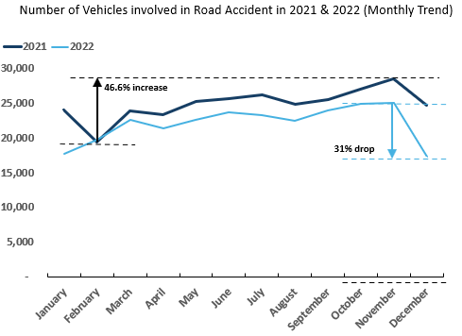

4

3

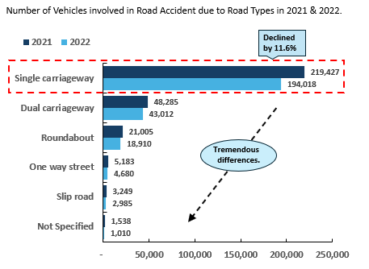

1. **Daylight's Grip!** In 2021, the majority of road accidents, totaling 74.5%9 (222,453), occurred during daylight hours. Similarly, in 2022, daylight still held a significant share, accounting for 75.9% (200,805), marking a 9.7% decrease year on year.
2. **Junction Peril:** In the UK, not at junction or within 20 meters, and T or staggered junction were the most dangerous junction details in 2021 and 2022 in terms of vehicles involved in road accidents. The two junction details amount to over 70% (197,423) on an average.

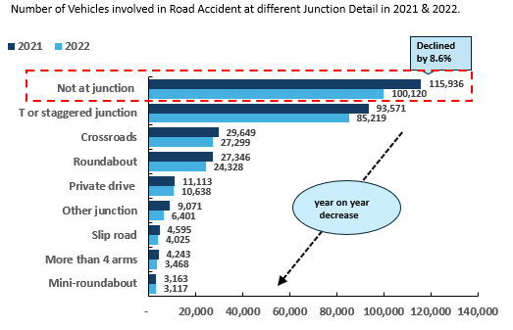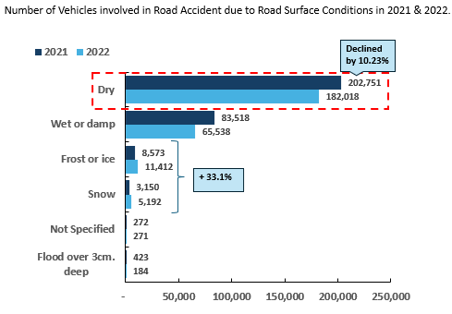

6

5

1. In both 2021 and 2022, urban areas witnessed a higher frequency of road accidents, averaging 63.8% (179,696). **That's a well-known fact, as vehicular transportation is more prevalent in urban areas compared to rural areas.**

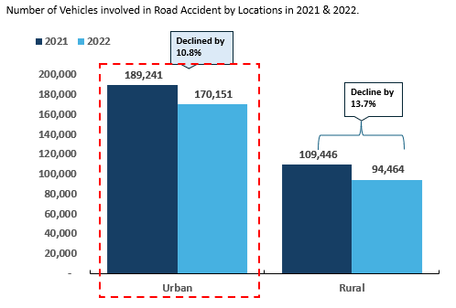

7

**We are nearing the final stretch of our journey**. **Now, let's examine another crucial aspect: Total Casualties Categorized by Severity of Road Accidents. Additionally, we will explore the correlation between the number of vehicles involved in accidents and the total casualties resulting from those accidents.**

Let's delve into the insights and visualizations.

1. **Amazing!** In 2021, slight accident casualties made up 83.55% of all road accident severities, and in 2022, slight severity remained significant, representing 84.72% of total casualties. This indicates a 10.65% reduction year on year. Regarding serious severity, there was a noticeable 16.18% decrease in the total cost of road casualties and accidents attributed to serious accidents in 2021 and 2022. Similarly, there was a 33.3% decrease in the total cost of road casualties and accidents related to fatal accidents during the same period, from 4,820 killed in 2021 to 2,855 killed in 2022.
2. **Alarming!** In both 2021 and 2022, cars accounted for the highest total road casualties by severity, comprising 79.80% (333,485). During this period, slight casualties decreased by 11.2%, serious casualties increased by 276.3%, and fatal casualties decreased by 30.4% (from 3,375 killed in 2021 to 2,350 killed in 2022). **That's a well-known fact since cars outnumber all other types of vehicles on the road.**

1

2

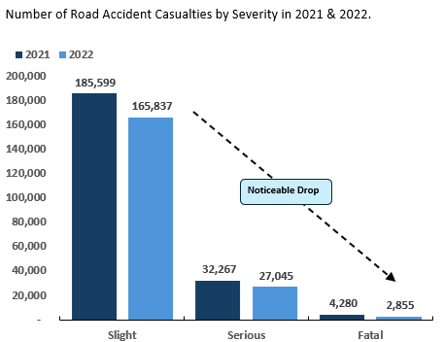

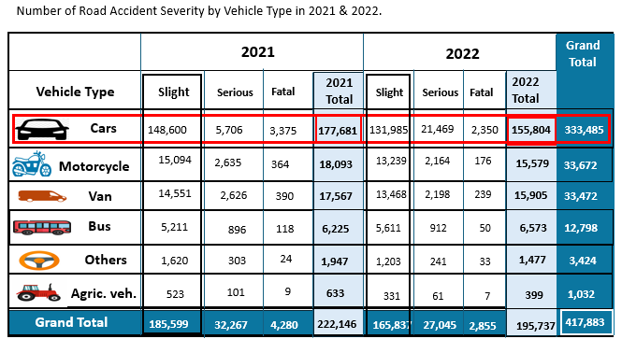

1. **Alarming!** In the UK, "Not at junction or within 20 meters" and "T or staggered junction" were identified as the most hazardous junction details in terms of road fatal accidents in both 2021 and 2022. Together, these two junction details constituted over 84% of the total, with a notable decrease of 32.3% observed in 2022. However, 3,618 were killed at these two junction details in 2021 and 2,450 killed in 2022.
2. **Urban Hazard:** In 2021 and 2022, urban areas consistently accounted for around 61.2% of total road accident casualties. Slight casualties decreased by 9.1% from 2021 to 2022, with slight casualties making up 52.6% in 2021 and 54.3% in 2022. Serious casualties averaged 7.3%, and fatal casualties averaged 0.1% across both years. **That's a well-known fact, as vehicular transportation is more prevalent in urban areas compared to rural areas.**

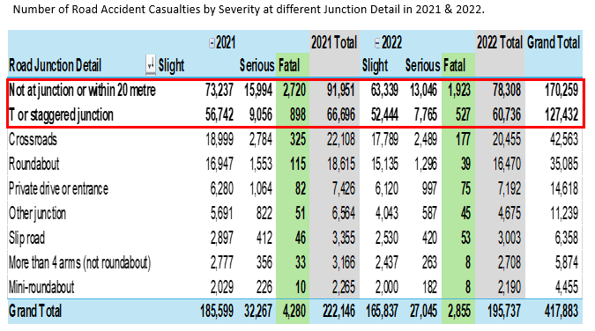

4

3

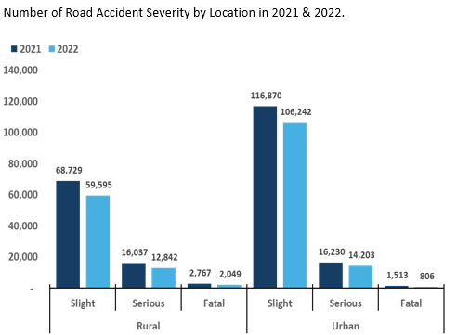

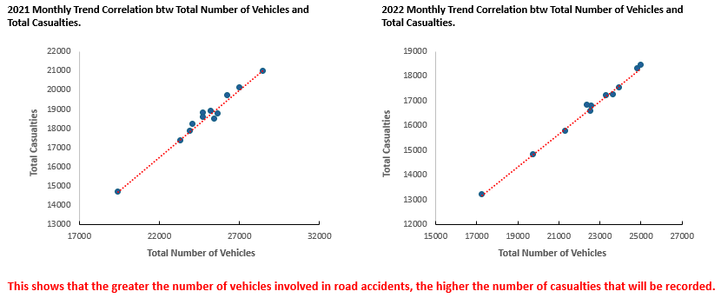**The Correlation between the number of vehicles involved in accidents and the resulting casualties is the statistical relationship between these two variables.** A positive correlation indicates that as the number of vehicles in accidents increases, casualties also tend to rise. A negative correlation suggests that as the number of vehicles increases, casualties decrease. No correlation means there is no predictable relationship. **Understanding this correlation can help identify patterns and guide measures to improve road safety and reduce casualties.**

**Positive Correlation**

**Positive Correlation**

**Economic impacts refer to the consequences of particular events, policies, or phenomena on a local, national, or even global scale.**

Let's analyse the economic cost of road accidents and casualties and explore their impact on the GDP of the UK through insights and visualizations.

1. The cost of fatal casualties is £1,930,329, while accidents cost £2,120,681. Serious casualties are estimated at £210,915, with accidents costing £246,109. Slight casualties have a cost of £16,722, while accidents cost £24,960.
2. In 2021, the total cost of road casualties and accidents in the UK amounted to £40.015 billion, while in 2022, it decreased to £31.000 billion, marking a significant drop of 11.4%. This decline underscores the effectiveness of efforts aimed at enhancing road safety.

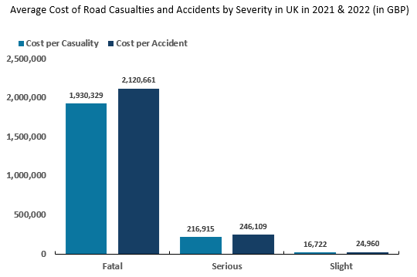

2

1

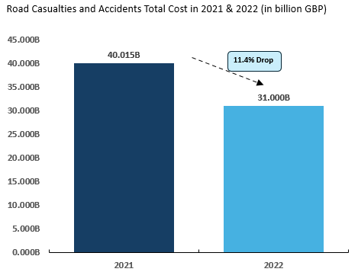

1. In 2022, the UK's GDP reached approximately £2.27 trillion, reflecting a growth of 4.32% from the £2.176 trillion recorded in 2021. This mirrors trends seen across Europe, where GDP growth rates experienced declines continent-wide in 2020, with a GDP of 2.002 trillion pounds due to COVID-19 pandemic.
2. The economic impact of road accidents on the UK's GDP decreased from 1.84% in 2021 to 1.37% in 2022. However, despite progress, the economic consequences of accidents remain a persistent concern.

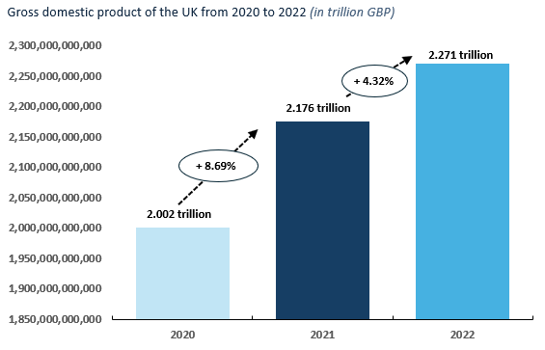

4

3

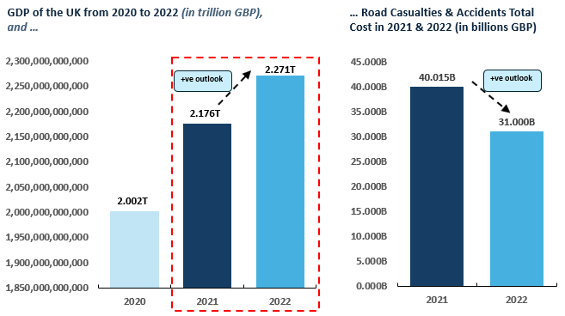

1. It's widely acknowledged that cars dominate the roads, making car accidents the most prevalent. This trend underscores the significant economic toll on the UK's GDP. In both 2021 and 2022, car accidents and casualties collectively impaired the UK's GDP by 1.46% and 1.1% respectively. Despite some advancements, the enduring economic repercussions of car accidents remain a pressing issue.

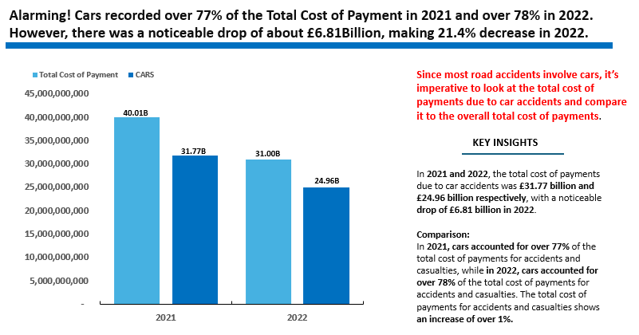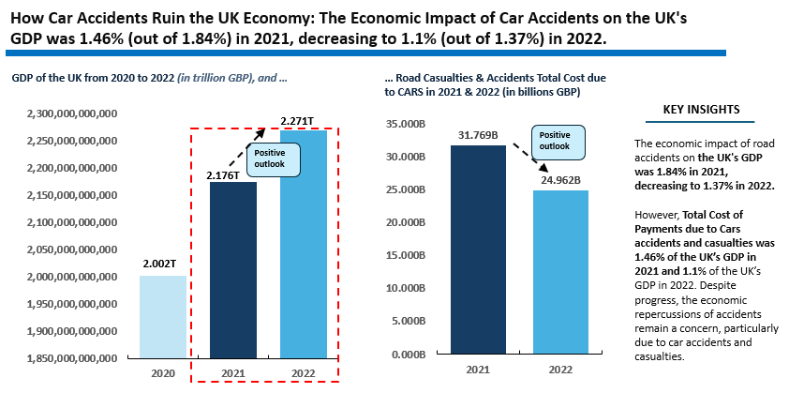

5

Let's now examine the economic impact of road accidents and casualties on the UK's GDP as we approach the conclusion of our journey. We're on the final stretch and almost at our destination. It has truly been quite a journey together.

**Economic effects of Road Accidents and Casualties on the UK’s GDP**

1. **Direct Costs of Road Accident:**

* Financial Impacts: Including medical expenses, vehicle repairs, legal fees, and insurance payouts.
* Economic Consequences: Such as the impact on GDP through reduced consumer spending and resource allocation to address aftermaths.

**2. Healthcare Costs of Road Accidents:**

* Personal and Social Costs: Covering individuals, families, and the strain on the healthcare system and government.
* Economic Ramifications: Including reduced productivity, resource allocation challenges, and opportunity costs.

**3. Productivity Loss due to Road Accidents:**

* Workforce Disruptions: Resulting in time off for recovery and diminished economic output.
* GDP Impact: Reflecting in decreased labour productivity, resource reallocation, and long-term effects.

**4. Human Capital Losses due to Road Accidents:**

* Workforce Challenges: Such as premature removal from the workforce and skill set depletion.
* Innovation and Development: With impacts on labour force reduction, long-term effects, and investment in education and training.

**5. Insurance Premiums due to Road Accidents:**

* Financial Burdens: Including increased premiums and reduced disposable income.
* Investment Challenges: Such as constraints on investment and potential impacts on economic growth.
* GDP Influence: Through both direct effects on insurance costs and broader indirect effects on the economy

**6. Environmental Costs of Road Accidents:**

* Air and Water Pollution: Resulting from vehicle emissions and oil spills, respective
* Economic Consequences**:** Such as resource diversion and additional healthcare costs affecting GDP.

**Now, let's focus on the home front and explore the recommendations regarding the strategic priority of reducing the economic impacts of road accidents and casualties on the UK's GDP. Additionally, let's identify the stakeholders who are crucially involved in this mitigation effort.**

**Recommendations**

**Strategic Priorities to Mitigate the Economic impacts of Road Accidents and Casualties on the UK’s GDP**

Managing the economic repercussions of road accidents and casualties on the UK's GDP demands a comprehensive strategy. Let's explore the strategic focal points.

1.Infrastructure Investment for Safer Roads.

2. Promoting Education and Awareness.

3. Strengthening Law Enforcement and Penalties.

4. Enhancing Emergency Response and Medical Services.

5. Utilizing Data for Informed Decision-Making.

6. Improving Insurance and Compensation Systems.

7. Integration of Road Safety in Urban Planning.

8. Addressing Environmental Concerns.

9. Driving Research and Innovation.

10. Fostering Collaboration and Leadership.

By emphasizing these initiatives, the UK can alleviate the financial fallout from road accidents, preserve human capital, and cultivate safer roadways for all. However, achieving this commendable goal requires the support of all stakeholders. Engaging stakeholders to mitigate the economic impact of road casualties and accidents on the UK's GDP is essential to this effort.

**Who are the Stakeholders to Mitigate the Economic Impact of Road Accidents and Casualties on the UK’s GDP?**

**The stakeholders are:**

1. **Government Authorities:**

* Ministry of Transportation
* Road Transport Department
* Emergency Services Department
* Traffic Management Agencies

1. **Regulatory and Enforcement Bodies:**

* Police Force
* Road Safety Corps

1. **Support and Service Providers:**

* Healthcare Providers
* Insurance Companies
* Technology Companies
* Transport Operators
* Media

1. **Community and Civil Organizations:**

* Road Safety NGO’s
* Educational Institutions
* Road Users

**Collaboration among these stakeholders is crucial for developing comprehensive strategies to mitigate road accidents and improve overall road safety in the UK.**

**Conclusion**

This report provides an in-depth analysis revealing that road accidents significantly impact the UK’s GDP, encompassing direct, indirect, and broader economic effects. To effectively address these impacts, a comprehensive strategy leveraging data-driven insights is essential. This strategy should include the implementation of enhanced safety measures, promotion of education and awareness, strengthening of law enforcement and penalties, improvement of emergency response and medical services, optimization of insurance and compensation systems, utilization of technological advancements, and enactment of effective policy interventions. Reducing the economic burden of road accidents will not only enhance public safety but also boost economic productivity and promote sustainable growth in the UK**.**

**See how this was done from the Comprehensive Presentation Slides**

Although this report is lengthy, it provides a concise overview of the steps I took during the project.

For a detailed account of the project's development, you can view my presentation slides on **LinkedIn -** [**https://www.linkedin.com/in/olumide-balogun1/**](https://www.linkedin.com/in/olumide-balogun1/) **or GitHub -** https://github.com/olumidebalogun1

**Contacts - BALOGUN OLUMIDE CHRIS.**

**Email: krisbalo11@gmail.com Tel: +234(0)8065060691**

**Tel: +234(0)8065060691**